TRUE DIALOGUE RESTORATIVE JUSTICE CENTRE
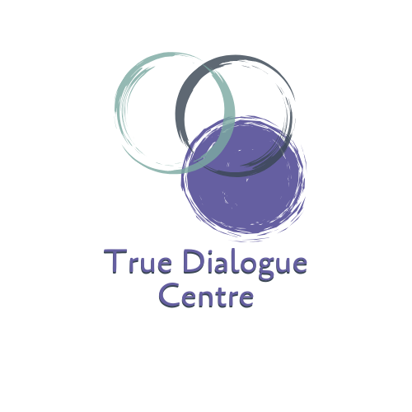
CALL FOR LOGO ART SUBMISSIONS
Alberta Indigenous Restorative Justice in Action (AIRJA)
We are searching for a powerful visual identity to match the impact of our work. We invite First Nation, Metis and Inuit artists across Alberta to create a logo that reflects the spirit of restorative justice, community healing, and Indigenous strength.
This artwork will become the cornerstone of AIRJA’s branding and will be used across our website, social media, outreach materials, and beyond.
The Vision
We’re looking for a logo that symbolizes:
- Restorative justice rooted in Indigenous knowledge
- Community, healing, and forward movement
- Connection to land, culture, and storytelling
What Happens to Your Art
- All submissions will be featured on the AIRJA website and social media with credit given to the artist by way of listing their name and community along with their artwork. Artists retain full copyright of their amazing work, and AIRJA will only feature it on our website and social media specifically for this call.
- The selected winner’s art will become the official AIRJA logo, representing the initiative across all platforms and formats. Colours and likeness of the artwork may be used to fully build out the branding of AIRJA.
Prizes/Honorarium
1st Place Grand Prize - $700
1st Runner up - $200
2nd Runner up - $100

How to Submit
Send your artwork to: rjcentre@truedialogue.ca
Please include:
- A short artist bio and story behind your design
- Your contact information
Deadline
Submission deadline is January 9, 2026

Best Practices for Submission
To ensure your artwork can be used across multiple platforms, please submit in one or more of the following formats:
- Vector files (.AI, .EPS, .SVG preferred for scalability)
- High-resolution raster images (.PNG, .JPG at 300 dpi)
- Transparent backgrounds if possible
- Keep your design adaptable for both color and monochrome use
- Please keep total email attachment size under 25MB
Medium
Digital designs are preferred for flexibility, but traditional mediums (painting, drawing, beadwork, etc.) are welcome—just be sure to submit a high-resolution photo or scan that showcases your piece clearly.
Let your creativity reflect the spirit of justice, healing, and Indigenous leadership. We look forward to witnessing your vision! Once you submit, you will receive an email confirmation within a couple of business days. If you have any questions, please email rjcentre@truedialogue.ca.

Please Note
Submissions must be original artwork created by the submitting artist. We are prioritizing authentic human artistic expression, especially given the cultural significance of this initiative. Artwork generated solely by Artificial Intelligence (AI) or Machine Learning (ML) tools, or where AI is the primary creative force, will not be considered. If you've used AI tools as a minor part of your process (say, for a little touch-up or brainstorming), please just be transparent and disclose it in your artist's statement.

